**Ex.No : 6**

**SELECT with various clause – GROUP BY, HAVING, ORDER BY**

**GROUP BY - HAVING**

1. Display the courseno and the number of students registered in each course if no of students registered is >1.

Ans)



2. Display the facno whose department is getting average salary greater than 25000

Ans)

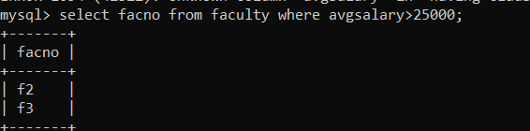

3.Retrieve Name, Gender, MobileNo of all the students in ascending order of RegNo.

Ans)

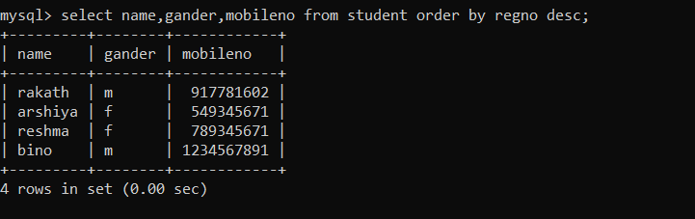

4.List the faculty members in the order of older faculty first.

Ans)

